**Terminal Information**

**Booklet**



**Shell Energy and Chemicals Park Rotterdam**

|  |  |  |  |
| --- | --- | --- | --- |
| **Revisie info** | **Laatste revisie** | **Datum** | **Reden** |
| **Oil / chemicals** | **A** | **01-02-2022** | **Eerste uitgave** |
| **Oil** | **B** | **01-04-2022** | **Europoort toegevoegd en tekstuele wijzigingen** |
|  |  |  |  |

**INTRODUCTION:**

In conjunction with these Shell Terminal Pernis Safety Book, the latest edition of the international edition of the International Safety Guide for Oil Tankers and Terminals and The Rotterdam, Port Authority regulations is applicable.

Tankers and their equipment must meet in accordance with the IMO BCH/IBC code guidelines. The criteria stated in this Safety Book do not relief the Tanker and/or Terminal from their obligation to use the best judgement when assessing the suitability of conditions for loading or discharging alongside Shell Terminal Rotterdam.

The master is responsible for the operation of his tanker including the cargo handling operations. He is to ensure that his staff who is delegated for the cargo operations are qualified and competent to do so. At all times, sufficient crew should be available onboard to keep an efficient and safe deck and cargo watch.

***Distribution List***

* *Port Authority*
* *Pilots (Head Office)*
* *Shipping Agent*
* *MTA*
* *Terminal Representatives/Shore Officers]*

Contents

**1.** **Fire and emergency response:** 7

**1.1** **EMERGENCY ALARMS AND ACTIONS:** 7

1 Fire and emergency response: 8

**1.1** **Emergency Alarms:** 8

**1.1.1** **In case of fire on the terminal or other ship** 8

**1.1.2** **In case of fire on the ship** 8

**1.1.3** **Fire alarm on the terminal** 8

**1.2**  **EMERGENCY COMMUNICATIONS:** 8

**2. SAFETY AND SECURITY** 10

**3. PRE-ARRIVAL COMMUNICATIONS** 12

**4.**  **ARRIVAL OFF PORT** 12

**5.3**  **MAXIMUM BEAM** 16

**5.4**  **AIRDRAFT:** 16

**5.5**  **TOTAL DISPLACEMENT ALONGSIDE JETTY:** 16

**5.6**  **DRAFT TO & FROM PERNIS:** 16

**5.8** **MAXIMUM APROACH SPEED** 17

**5.9**  **LAY BY BERTH** 17

**5.10**  **MOORING ALONG THE JETTY** 17

**5.11**  **RULES FOR MOORING IN GENERAL** 17

**5.12 RESTRICTION** 18

**5.13**  **EMERGENCY TOWING OFF PENDANTS (ETOPS OR FIRE WIRES)** 18

**7. Responsibilities:** 20

**7.1**  **JURISDICTION:** 20

**7.2**  **CONDITIONS OF SHIP ACCEPTANCE:** 21

**7.3**  **RESPONSIBILITIES FOR LOADING:** 21

**7.4**  **RESPONSIBILITIES FOR UNLOADING:** 21

**8**  **operations alongside:** 21

**8.1**  **GENERAL:** 21

**9. Dimensions Jetties & Connections** 22

**Electrical Storms:** 24

**9.3** **EMERGENCY SHUTDOWN:** 24

**9.4**  **DRY CERTIFICATES’:** 24

**9.5**  **HANDLING OF SHIP’S STORE AND SPARE GEAR:** 24

**9.6**  **CRAFT ALONGSIDE:** 25

**9.7**  **GARBAGE RECEPTION FACILITIES:** 25

**9.8**  **POTABLE WATER:** 25

**9.9**  **BUNKERS AND LUBRICATING OILS:** 25

**9.10**  **SLOPS AND BALLAST RECEPTION FACILITIES:** 26

**9.11**  **LOADING & DISCHARGING AGREEMENT:** 26

**9.12** **ADDITIONAL DANGEROUS PRODUCT INSTRUCTION:** 26

**9.13**  **STATIC ELECTRICITY:** 26

**9.14**  **IF A FLAMMABLE MIXTURE IS PRESENT THEN:** 27

**9.15**  **EMPTYING LINES** 27

**9.16** **DEPARTURE / ORDERING PILOT & BOATMEN:** 27

**10**  **Safety Requirements:** 27

**10.1**  **SMOKING:** 27

**10.2**  **USE OF MATCHES AND LIGHTERS:** 28

**10.3**  **MANAGING SHIP-/SHORE INTERFACE:** 28

**10.4** **HSE LETTERS OF PROTEST:** 28

**10.5**  **TERMINAL EVALUATION BY SHIP:** 28

**10.6**  **ACCESS TO SHIP & CLEANLINESS SHIPS DECK:** 29

**10.7**  **ENTERING ENCLOSED SPACES:** 29

**10.8**  **INSPECTION AND/OR DIVING ALONGSIDE JETTIES:** 29

**10.9**  **DRUG AND ALCOHOL POLICY:** 29

The use of alcohol and or drugs while working is prohibited 29

**10.10**  **PORTABLE ELECTRICAL EQUIPMENT, INCLUDING PHONES AND PAGERS:** 29

**10.11**  **ENVIRONMENTAL PROTECTION:** 29

**11**  **applicable terminal regulations:** 29

**11.1**  **ULLAGING AND SAMPLING:** 30

**11.2**  **CLOSED OPERATIONS:** 31

**11.3**  **STATE OF READINESS OF MAIN ENGINES:** 31

**11.4**  **MAINTENANCE AND REPAIR WORK ONBOARD:** 31

**11.5**  **HOT WORK ON BOARD:** 31

**11.6**  **TANK CLEANING, PURGING AND GAS FREEING:** 31

**APPENDIX A: CONTACT LIST:** 32

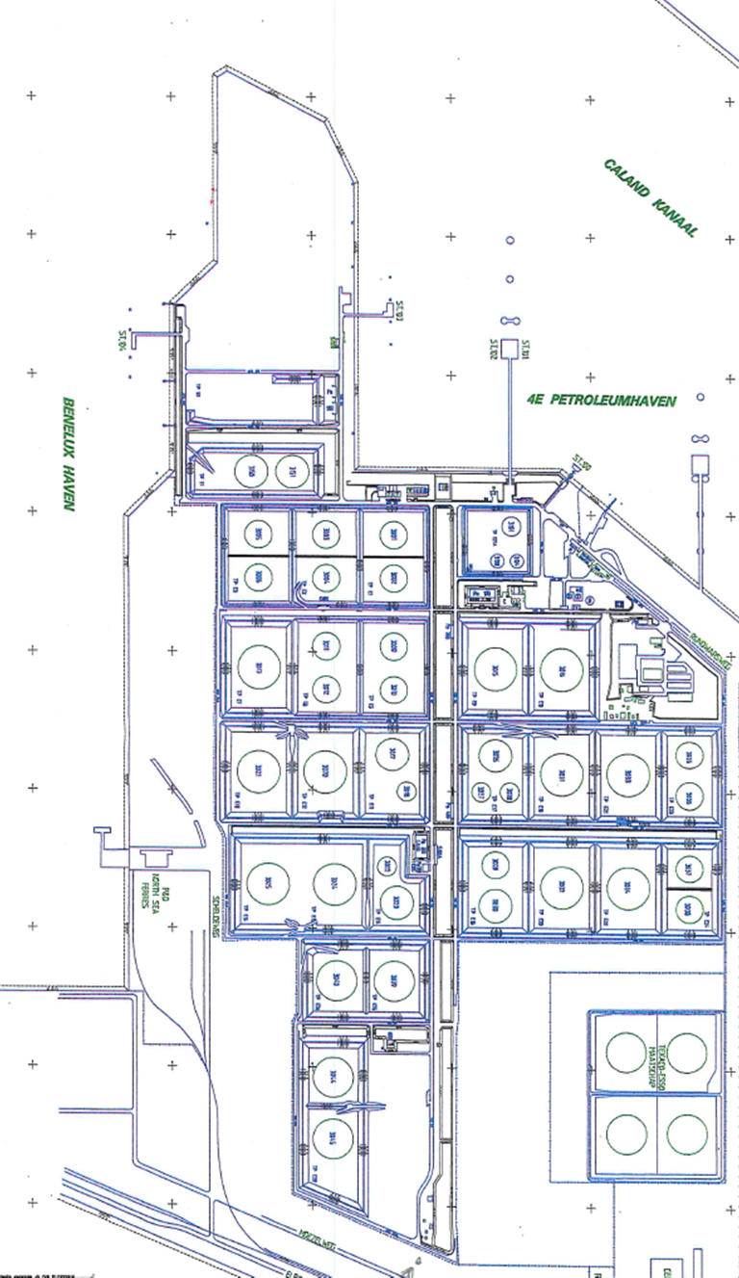

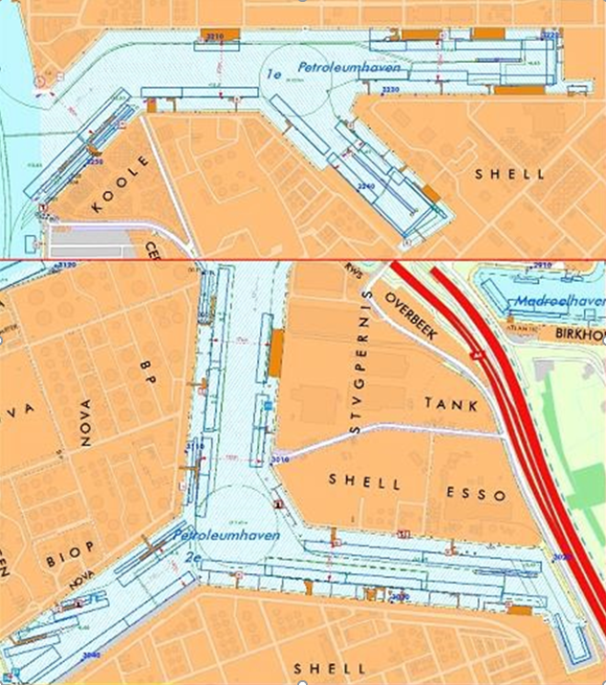

1. **Fire and emergency response:** 
   1. **EMERGENCY ALARMS AND ACTIONS:**

|  |  |
| --- | --- |
| ***ACTION-SHIP*** | ***ACTION-BERTH*** |
| ***Emergency on your ship*** | ***Emergency on a ship*** |
| • *Raise the alarm:*  *Sound one or more blasts on the ships whistle, each blast of not less than 10 seconds duration supplemented by a continuous sounding of the general alarm system.* | • *Raise the alarm* |
| • *Inform Terminal Representative* | • *Contact ship* |
| • *Inform all ships in the vicinity* |
| • Contact Port Authorities via CIN |
| • *Cease all cargo/ballast operations and close all suitable valves if discharging. If loading only close valve after terminal advise it is safe to do so, after stopping their pumps.* | • *Cease all cargo operations and close all suitable valves* |
| • *In case of fire, fight fire and prevent from spreading* | • *If necessary, stand by to assist fire fighting* |
| • *Stand by to disconnect hoses or marine loading arms* | • *Stand by to disconnect hoses or loading arms* |
| • *Bring engines to standby* | • *Implement berth emergency plan* |
|  |  |
| ***Emergency on another ship*** | ***Emergency ashore*** |
| *Stand by, and when instructed:* | • *Raise alarm* |
| • *Cease all cargo/ballast operations and close all valves. If loading only close valve after terminal advise it is safe to do so, after stopping their pumps.* | • *Cease all cargo operations and close all valves* |
|  | • *In case of fire, fight fire and prevent it from spreading* |
| • Stand by to d*isconnect hoses or marine loading arms* | • *If required, stand by to disconnect hoses or marine loading arms* |
| • *Bring engines and crew to standby, ready to unberth* | • *Implement berth emergency plan* |

### 1 Fire and emergency response:

**1.1 Emergency Alarms:**

**1.1.1 In case of fire on the terminal or other ship**

1. Sound one or more blasts on the ships whistle, each blast of not less than 10 seconds duration supplemented by a continuous sounding of the general alarmsystem.
2. Contact the **Central Site Emergency Controlroom**
3. Stand by to cease all cargo operations and then close all valves
4. Stand by to disconnect hoses or arms
5. Stand by to start engines

**1.1.2 In case of fire on the ship**

1. Raise alarm
2. Inform terminal
3. Fight fire and prevent fire spreading
4. Stand by to cease all cargo operations and then close all valves
5. Stand by to disconnect hoses or arms
6. Stand by to start engines

**1.1.2.1 Emergency respons in case of fire on a ship.**

In case of a fire emergency on a ship the Shell emergency Response personel will concentrate the response on the Shell asset . The authorities, who will take over command in such a situation will decide what to do with the vessel and her crew.

**1.1.3 Fire alarm on the terminal**

Fire alarm: Sirene with alternating frequency (sinus wave)

All save signal: Continuous high pitch sound during 1 minute

Testing fire alarm: Monday at 12:00 hrs

**1.2 EMERGENCY COMMUNICATIONS:**

At the Shell Netherlands Terminal Oil Movement berth, the primary method of communication will be via the UHF radio provided by the terminal to ships on their arrival alongside.

The terminal will provide the ship with a portable radio, set on the loading office frequency. The ship will sign a receipt which will be countersigned for receipt by the shore upon returning the set to the shore representative. Also, during the ship-shore loading and discharging conference the Loadingmaster will write down the mobile number of the ship mobile phone. However, in case of a non-communication occasion the loading and discharging needs to be stopped by the ship on a safe way.

Europoort Loadingmaster +31.10.431.1240

Europoort Control room +31.10.431.1280

Refinery Oil Movement Control room: +31.10.431.3929

Chemicals Loadingmaster: +31.10.431.1670

Chemicals Control room: +31.10.431.4250

**1.3.1 International Shore Fire Connection.**

The Terminal has International Shore Fire Connections conform ISGOTT appendix E available on the jetties. If the fire alarm is raised the fire water grid on the terminal will be pressurized from minimum 8 bar up to 13 bar maximum.

**1.3.2 Evacuation /Muster points**  

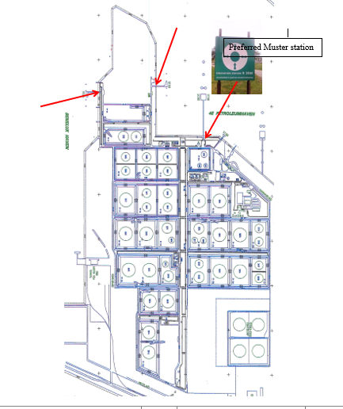

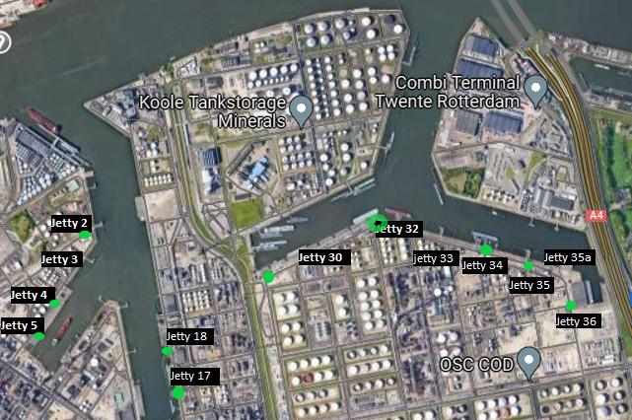

**1.3.3** Evacuation points (muster stations) are created at the far end of our jetty heads, see muster signs. Boatman craft on site is available.

In case of vessel is required to be removed from our jetty then first clear communication should be established between ships master and Loadingmaster to discuss this operation. The following items should be considered: tugboat -, boatman assistance, release of ropes.

In case of an emergency and an evacuation is required and access to main entrance is not blocked the muster station near the jetty should be considered. See also the evacuation plan in section 1.3.2 of this document

**2. SAFETY AND SECURITY**

**2.1 General**

Responsibility for the safe conduct of operations whilst a ship is alongside the Berth rests jointly with the Master of the ship and the responsible Oil and chemicals Loading master.

We wish therefore, before operations start, to seek your full co-operation and understanding of the safety requirements set out in the Ship/Shore safety checklist, which are based on safe practices that are widely accepted by the oil and tanker industries.

We expect you, and all under you command, to adhere strictly to these requirements throughout your vessels stay alongside Shell jetties and we, for our part, will ensure that our personnel do likewise, and co-operate fully with you in the mutual interest of safe and efficient operations.

Before commencing operations, and every 4 hours as stated repetitive items of the Ship/Shore safety checklist, a terminal representative together with a vessel representative, will make a routine inspection round on your vessel to ensure that all elements addressed within the scope of the Ship/Shore safety checklist are being managed in an acceptable manner. Where corrective action is needed, we will not agree to operations commencing or, should they have started, we will require them to be stopped.

If you consider that safety is being endangered by any action on the part of our staff or by any equipment under the control of the Shell Terminal Oil Movement, you should demand immediately for cessation of operations.

**THERE CAN BE NO COMPROMISE WITH SAFETY!**

**2.2 Personal Protective Equipment (PPE)**

The following minimum dress code shall be adhered to by ship’s personnel while on duty alongside the Berth:

Boiler suit / coverall

Safety Helmet

Safety goggles

Safety shoes or boots with steel toe caps.

Life jacket or buoyancy aid when working outside safety rails.

Personnel engaged in operations are actively encouraged to use above mentioned PPE at all times during cargo transfer, hose handling and mooring operations. This includes the wearing of safety goggles.

When handling cargoes with additional hazards, e.g., H2S, additional PPE are required i.e., H2S warning devices and escape mask.

* 1. **Port and Terminal Security**

This is to inform you that as from 01-07-2004 Shell Energy and Chemicals Park Rotterdam wishes to comply with the provisions of the International Ship & Port Facility Security Code.

You are therefore invited to complete the provided Declaration of Security (if this is necessary), together with our representative who is acting on behalf of the Port Facility Security Officer of the installation. You may wish to use your own DOS; we will accept this provided it is in every detail identical to the template, as mentioned as Appendix 1 in the Appendix to part B of the code.

Should you require any further security-related information, please feel free to contact our security-office

* 1. **Personnel and Vehicular Access**

* + 1. **Access to SHELL ENERGY AND CHEMICALS PARK ROTTERDAM Pernis**

Prior to arrival ship’s crew and expected visitors must be reported in writing (i.e., current crew list) to Site Security via e-mail [PER-Beveiliging-Poort-5@shell.com](mailto:PER-Beveiliging-Poort-5@shell.com)”. Persons of which Terminal Security isn’t notified are denied access to the Shell site. If external medical assistance (e.g., in case of a personal accident) is called in, please advise the Loadingmaster so he can inform site security about their arrival.

Technicians and ship chandlers must report and identify themselves to site security at the gate.

* + 1. **For ships moored alongside Shell Energy and Chemicals Park jetties**

In order to control the persons allowed to board/disembark the vessel, as well as for general security reasons, identification is required for legitimation by all crewmembers. For this purpose, a passport or seaman book is required and should be shown at the gate. Furthermore, we request you to inform us about the representatives of firms and the visitors you wish to have on board, so they can be added to the crew list.

* + 1. **Entering the terminal from the ship**

Access to the Shell Terminal is not allowed other than for staff involved in the cargo transfer. Therefore, visits to the shore by crewmembers must be arranged via the ship 's Agent. The Agent will inform the Shell Installation security via e-mail PER-Beveiliging-Poort-5@shell.com” about the shore visit and arranged transport. Accordingly, Shell Security Department will allow access for arranged transport on the Installation to pick-up or deliver crew at the jetty.

* + 1. **Entering the jetties from the shore**

Before entering the jetties or loading areas one must report themselves to the Control Room. Entering jetties during mooring and unmooring is for safety reasons not allowed. Mooring and unmooring is an activity with increased risk where only the presence of specialized people is accepted. When mooring of the ship and placing of the gangway is completed, the jetty operator will, via the Control Room, release the jetty for access

**3. PRE-ARRIVAL COMMUNICATIONS**



**3.1 ETA Advice**

The vessels agent will contact the Shell Oil Loadingmaster via telephone at least 60 minutes before the vessel arrives at the Pilot station to establish whether the berth will be available.

The 60-minute Notice also applies when vessels shift from berths within the Rotterdam area.

This will enable the terminal to communicate status of the berth or any delay due to unforeseen circumstances and also to issue final directives*.*

**3.2 Pre-Arrival Exchange of Information**

Pre-arrival exchange of information will take place when vessels are scheduled for Shell Energy and Chemicals Park jetties.

An e-mail containing information concerning the arrival and berth will be sent to the vessel via the vessel’s agent.

This e-mail also contains a questionnaire for the vessels Master to be filled out and returned to the terminal via the vessel’s agent.

**4. ARRIVAL OFF PORT**

**4.1 Berth Approach**

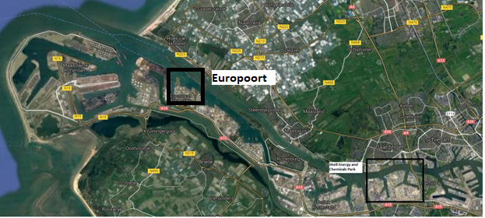

**4.2 Pilotage Anchorage and Waiting Areas**

Seagoing vessels of >70 metre. and/or carrying hazardous materials are obliged to have a pilot on board in order to sail into the Rotterdam

<https://www.portofrotterdam.com/sites/default/files/2022-02/port-information-guide.pdf>

**5. BERTHING AND MOORING**

**5.1 General Description of Berth**

Shell Europoort, has 4 dedicated jetties for seagoing vessels and one dedicated for inland

barges only

Jetty 100 for inland barges, jetty 101, jetty 102 and jetty 103 for seagoing vessels which are

located in the 4th Petroleumhaven and jetty 104 for seagoing vessels which is located in the

Beneluxhaven

Shell Energy and Chemicals Park Rotterdam, has 12 dedicated jetties and 1 quay sides,

jetty 2, 3, 4, 5, 17, 18 and 15 only for barges which are located in the 1st Petroleumhaven

jetty 32, jetty 33, 34, 35, 35a, 36 and Quay 30 which are located in the 2nd Petroleumhaven.

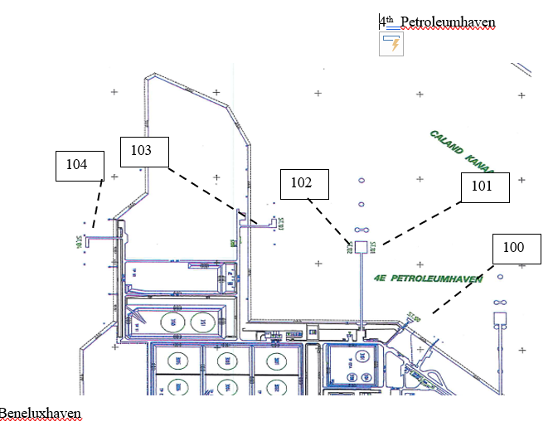

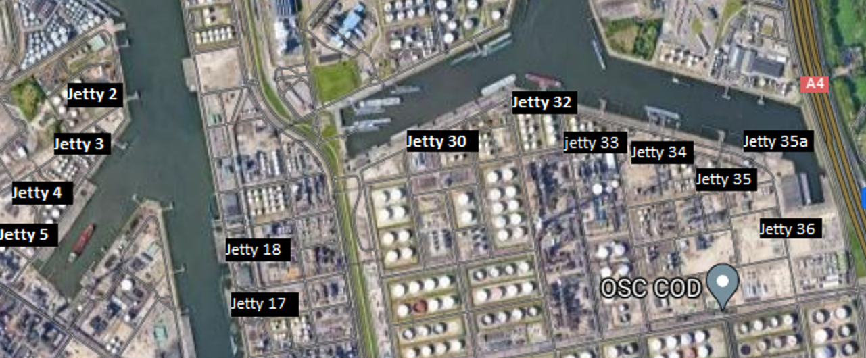

**5.2 Berth Limitations**

**4th Petroleum Harbour – Shell Europoort**

|  |  |  |  |  |
| --- | --- | --- | --- | --- |
| Maximum length, draft (fresh water) | | | |  |
| Jetty | Minimum length (M) | Maximum length (M) | Maximum draft (M) Salt | Maximum Displacement per jetty |
| 100 | 70 | 110 | 3.38 | 6000 |
| 101 | 120 | 305 | 13.38 | 100000 |
| 102 | 170 | 305 | 15.23 | 120000 |
| 103 | 140 | 366 | 16.38 | 350000 |
| 104 | 170 | 366 | *22.13 | 350000 |

**1st Petroleum Harbour – Shell Energy and Chemicals Park Rotterdam**

|  |  |  |  |  |
| --- | --- | --- | --- | --- |
| Maximum length, draft (fresh water) | | |  |  |
| Jetty | Minimum  length (M) | Maximum length (M) | Maximum draft (M) Fresh | Maximum  Displacement mooring per jetty |
| 2 | 99 | 190 | 11.40 | 25.000 |
| 3 | 99 | 155 | 11.40 | 18.000 |
| 4* | 85 | 185 | 10.55 | 25.000 |
| 5 | 85 | 111 | 9.55 | 4.000 |
| 15 | 60 | 90 | 5.55 | 4.000 |
| 17 | 85 | 190 | 9.55 | 55.000 |
| 18 | 85 | 185 | 9.55 | 45.000 |
| **\***For Hydrowax max 130m | | | | |

**2nd Petroleum Harbour – Shell Energy and Chemicals Park Rotterdam**

|  |  |  |  |  |
| --- | --- | --- | --- | --- |
| Maximum length, draft (fresh water) | | |  |  |
| Jetty | Minimum  length (M) | Maximum length (M) | Maximum draft (M) Fresh | Maximum  Displacement mooring per jetty |
| 32 | 85 | 160 | 10.90 | 40.000 |
| 33 | 109 | 185 | 11.50 | 50.000 |
| 34 | 85 | 190 | 11.50 | 50.000 |

|  |  |  |  |  |
| --- | --- | --- | --- | --- |
| 35 | 75 | 185 | 10.90 | 50.000 |
| 35a | 75 | 129 | 5.55 | 7.500 |
| 35a**\*** | 75 | 136 | 5.55 | 7.500 |
| **\*** only for barges | | | | |

|  |  |  |  |  |
| --- | --- | --- | --- | --- |
| Maximum length, draft (fresh water) | | |  |  |
| Quay | Minimum  length (M) | Maximum length (M) | Maximum draft (M) Fresh | Maximum  Displacement mooring per jetty |
| 30 LP 1-6 |  | 147 | 5.55 | 13.700 |
| 30 LP 7 |  | 147 | 6.40 | 13.700 |

**5.3 MAXIMUM BEAM**

There is no restriction regarding beam, with exception of barges calling to a Jetty 35a where maximum breath is 25 m.

Not every berth can accommodate maximum size vessels, check the berth information first.

**5.4 AIRDRAFT:**

There is no air draft/overhead clearance restriction / limitation

**5.5 TOTAL DISPLACEMENT ALONGSIDE JETTY:**

Be aware that the total displacement on arrival is taken into account for forces against jetty.

**5.6 DRAFT TO & FROM PERNIS:**

[Port of Rotterdam | Rotterdam Port Authority](https://www.portofrotterdam.com/en)

**5.7 Tugs and Towage**

The number of tugs available may vary throughout the year, and the numbers mentioned below are averages.

Bollard pull 28 – 45 Tons: Number of tugs 13

Bollard pull 50 – 65 Tons: Number of tugs 15

Bollard pull 70 – 80 Tons: Number of tugs 5

Tugboat types: conventional, ASD-type and tractor tugs.

All the tugs are equipped with proper rubber fenders on the front and the stern.

The principal purpose of a harbour tug is helping to control ships during the transit of narrow channels, in turning basins and for careful controlling during the final stages of coming alongside a berth.

Safe use of harbour tugs is the responsibility of the ship’s master, under a pilot's advice and this pilot’s advice for the terminal Pernis is mandatory

.

General: for a ship <10.000 t SDWT fitted with a good working bow propeller with enough power, will not need a tugboat in normal conditions. However, Tug usage depends on factors that include the following:

* the full range of vessel sizes and types to be handled.
* type of tug propulsion and engine configuration.
* the need to physically swing the ship in narrow turning basins.
* requirements for escort and assist duties.
* the need to control velocity; and,
* environmental conditions (e.g., wind, sea, swell, current, ice).

* 1. **MAXIMUM APROACH SPEED**
* The max approach speed to jetties is 0.10 m/sec = 0.02 NM/hr.

**5.9 LAY BY BERTH**

Shell doesn’t have lay by berths. Arrangements for Lay by berths can be made via vessels agent.

**5.10 MOORING ALONG THE JETTY**

Normally ships will berth according to the “bow out”-principle. Deviating from this rule can occur because of other vessels and/or optimizing jetty equipment availability. It is recommended that the pilot contacts the Loadingmaster by mobile phone for assurance.

The Harbour Master can permit deviation from this rule.

**5.11 RULES FOR MOORING IN GENERAL**

* Breast lines should be oriented as perpendicular as possible to the longitudinal Centre line of the vessel and as far aft and forward as possible
* Spring lines should be oriented as parallel as possible to the longitudinal Centre line of the vessel
* The vertical angle of the mooring lines should be kept to a minimum
* Generally, mooring lines of the same size and type (material) should be used for all leads. If this is not possible due to the available equipment, all lines in the same service, i.e., breast lines, spring lines, headlines, etc. should be the same size and type. For example, all spring lines could be wire and all breast lines synthetic.
* Mooring lines should be arranged so that all lines in the same service are about the same length between the vessel’s winch and the shore bollard. Line elasticity varies directly with line length and shorter lines will take more load.

Minimum mooring requirements Seagoing vessels:

* Ships up to 10.000 Dwt: 2 Head- and Stern lines, 2 Spring lines Fore and Aft
* Ships up to 25.000 Dwt: 3 Head- and Stern lines, 2 Spring lines Fore and Aft
* Ships over 25.000 Dwt: 4 Head- and Stern lines, 2 Spring lines Fore and Aft
* SDWT is mentioned because of the common notation.
* Although SDWT is mentioned, be aware that the total arrival displacement is taken into account for forces against jetty.

Link to Jetty drawings:

**https://www.Shell Energy and Chemicals Park Rotterdam-bbs.nl/port-information-mooring-plans/**

**5.12 RESTRICTION**

When in a part of the Rotterdam area visibility decreases to less than 500 meters, the Department of Vessel Traffic & Operations (VTS) will enforce the following rules:

- visibility between 200 and 500 meters: if the ship requires tugs, the Department of Vessel Traffic & Operations will consult the pilot association and tugboat companies as to whether the ship can sail

- visibility less than 200 meters: the Department of Vessel Traffic & Operations will always contact the pilot as to whether the ship can sail

-

Traffic guidance is supplied by VTS when visibility is less than 1,000 meters on the river or less than 2,000 meters in the approach area and Europoort.

**5.13 EMERGENCY TOWING OFF PENDANTS (ETOPS OR FIRE WIRES)**

This item is still on the ISGOTT checklist. However, as OCIMF advises to discontinue this practice, this item is not being enforced in the Port of Rotterdam.

**6. COMMUNICATIONS WHILE BERTHED**

**6.1 General**

Responsibility for the safe conduct of operations whilst your ship is alongside our terminal rests jointly with you, as Master of the vessel, and with the Terminal Loadingmaster.

We wish therefore, before operations start, to seek your full co-operation and understanding of the communication procedure.

Shell Terminal wants full co-operation with you in the mutual interest of safe and efficient operation.

* There must be a continue radio communication established during the entire stay of the vessel alongside Shell Terminal
* The officer engaged in cargo operations should always be in contact with the Terminal Loading Master
* A radio check should be conducted every hour
* A lack of communication results in cessation of the cargo operation
* The battery exchange will be arranged by loading master every 8 hours
* Communication language is English

To enable contact between ship and Terminal Movement control room we will issue a portable radio set to the ships officer. This will enable him to contact the Terminal Movement control room to report/discuss progress of operations, report unsafe situations and calamities. Please address the Terminal Movement control room in the following manner:

"Control room here the 'Vessel name'. Please come in"

As a back-up for the portable radio set an intrinsically safe mobile phone will be issued. The numbers that are needed for a safe communication are pre-programmed for oil Jetties.

**6.2 Ship/Shore Safety Check List and Operational Agreements**

On arrival at the berth, the Terminal representative will present the ship with a copy of a folder containing the following documents:

* Safety Letter to Master
* Emergency Procedure Notice
* Ship/Shore Safety Check List
* Cargo Transfer Plans
* Port Security Requirements

The various forms, information and procedures laid out in the document formalize the conduct and procedures governing ship/shore operations at the jetty which are to be mutually agreed before operations commence.

The agreements reached in the document remain in force throughout the time your vessel remains alongside the Petroleum Berth. Any changes made to these agreements during the course of the cargo operation must be again agreed in writing.

All items contained in the Ship/Shore Safety Check List must remain constantly under review. However, the ship and shore are required to jointly recheck those items requiring formal recheck at intervals not exceeding 4 hours.

**6.3 Communications during Cargo Transfer**

The terminal will provide the ship with a portable radio set on the shore control room frequency and an intrinsically safe mobile phone. The ship will sign a receipt which will be countersigned for receipt by the shore upon returning the set to the shore representative.

During cargo operations, if for any reason it becomes necessary to stop cargo in an emergency, the party requesting the stop should notify the other party by UHF radio, or any other means, requesting ‘Emergency Stop’.

All transfer pumps must be immediately stopped, and ship and shore manifolds closed until the situation is investigated and joint agreement is reached on resuming operations.

During the pre-transfer conference, communications procedures will be agreed for conducting specific activities and will include agreed notice periods for conducting ship or shore stops.

Also, during the pre-transfer conference, the Loadingmaster will write down the mobile number of the ship mobile phone. However, in case of a non-communication occasion, the loading and discharging needs to be stopped by the ship on a safe way.

**7. Responsibilities:**

**7.1 JURISDICTION:**

The Pernis Port is within the jurisdiction of the Port of Rotterdam. Therefore, the vessel could be subject to inspection by inspectors of the Transport and Environmental Safety Department or Port State Control. Because port operations take place around the clock, these inspections take place during day- and night-time. Our experience has learned that on many occasions, especially during the night, documentation or certificates were not available. To ensure a smooth operation, we advise to keep the following documentation and certificates (or certified copies of certificates) available at all times.

* IOPP
* SOPEP
* Shipboard marine pollution emergency plan
* Garbage record book
* Oil record book part I and II
* Certificate of Fitness chemical/gas, including product list
* Procedures and arrangements manual
* Cargo record book
* Safety checklist
* Stowage plan on arrival and departure
* Material safety datasheet (s)
* Bill of lading
* Shipping document for bulk liquid cargoes

**7.1.1 Inspections from port state control:**

The Paris Memorandum of Understanding (MOU) on Port State Control aims at eliminating the operation of sub-standard ships through a harmonized system of Port State Control inspections on foreign ships in the Paris MOU ports. The organization consists of 25 participating member states and covers the waters of the European coast and the North Atlantic basin from Canada to Europe.

The Dutch Port State Control is carried out by the Transport and Water Management Inspectorate of the Netherlands. It deals with approximately 1,400 inspections each year. Inspections take place on board, ensuring that these ships meet international safety, security and environmental standards, and that crewmembers have adequate living and working spaces

**7.2 CONDITIONS OF SHIP ACCEPTANCE:**

Ships are accepted at Shell Pernis on the understanding that operations will be conducted in accordance with all applicable legislation, together with practices contained in relevant Codes of Practice, in particular, the guidance contained within the latest edition of the International Safety Guide for Oil Tankers and Terminals (ISGOTT).

**7.3 RESPONSIBILITIES FOR LOADING:**

Shell Energy and Chemicals Park Rotterdam is responsible for the operational handling of ships alongside the jetties. The captain/skipper of a ship remains legally responsible for the activities on board of the vessel.

**7.4 RESPONSIBILITIES FOR UNLOADING:**

The terminal will monitor Loading & discharging operations.

**8 operations alongside:**

**8.1 GENERAL:**

**8.1.1 Personal attendance of jetty operator on the jetty:**

During your stay along our jetty a jetty operator will be permanently monitoring the vessel through CCTV during active loading and discharging operations. He or she will also assist (dis)connecting hoses/loading arms and will start or stop operations in full cooperation with the ship’s cargo officer. The jetty operator is in continuous radio contact with our Control Room and will supervise the loading and discharging activities on our behalf.

The jetty operator will periodically visit your ship in order to discuss progress of operations and carry out inspections (repetitive checks) on board of your vessel and shore, conform the ship shore safety checklist. When unsafe situations or calamities occur, he or she will, in cooperation with the vessels crew, take care that loading/discharging operations are immediately and safely stopped.

**8.1.2 Camera surveillance with remote control of cargo systems:**

During your stay along our jetty loading and discharging operations are under continuous camera surveillance from our staff in the Control Room. The cargo facility itself is remotely controlled from the same Control Room. One of our staff will periodically visit your ship in order to carry out inspections (repetitive checks) on board of your vessel, and shore, conform the ship shore safety checklist.

**9. Dimensions Jetties & Connections**

For efficiency reasons we request the agent to transmit the dimensions of the shore connections to the ship which should be copied onto the ship’s cargo connection before arrival at our terminal

| **Jetty** | **Load. arms** | **Load. Arm no.** | **Size** | **Rate m3/hour** | | **Product** | **Max. backpressure** |
| --- | --- | --- | --- | --- | --- | --- | --- |
| **Discharging** | **Loading** |
| 101 | 2 | 1 + 2 | 12” ASA | 3.500 | 1150 | Naphtha | 10 bar |
| 102 | 3 | 1 + 3 + 4 | 12" ASA | 7.500 | 3.000 | Crude | 10 bar |
| 103 | 2 | 2 + 4 | 16” ASA | 10.000 | 3.000 | Crude | 10 bar |
| 2 | 1 + 3 | 16” ASA | 7.400 | 2.900 | Gas oil | 10 bar |
| 104 | 3 | 2 + 3 + 4 | 16” ASA | 15.000 | 3.000 | Crude | 10 bar |
| 1 | Spare | 16" ASA | 5.000 | 2.500 | Crude | 10 bar |

Jetty 2

Catfeed (VGO) and Bitumen

Jetty 3

Catfeed (VGO)

Jetty 4 - liquid

Heptane /hexane/pentane

Iso hexane/iso n-pentane

Hydrowax (STR)

Sovents (shellsolen)/GTL

Jetty 5

Sulphur (inland barges only)

Jetty 15 +16

Only Hexion discharging with barges

caustic soda

Sulfuric acid

Calcium oxide powder

Jetty 17 - liquid

DIBK GTL /IPA

Ethyl proxitol / MIBK / MPG / DMK

DMK/phenol/

prop. Trimers /xylene (Hexion)

Jetty 18 – Liquid

Caradolen/ DMK / ethyl proxitol

IPA MIBC / MIBK / MPA / MPG

DIB/ECH/ prop.Trimers/versatic (Hexion)

Jetty 32

Alkylate, Avgas, BOB import, BOB export, DES LCO, DES HGO, DES LGO

Diesel B0 / B7, Fuel HS , Gasoil (DIN blend), GOC, HCCCO, HCU Tops, HS HGO, HS LGO,

IMF (Intermediate Fuel, JET A1, LCCCO (light cat cracked cycle oil), LCCG (=CCTops), Light Platformate, Long residue, LS HGO, LS LGO, Naphta / Platfeed / chemfeed, Phenolic H'cut (off spec CC Tops T1115),Platformate Light, Platformate medium, Platformate Full right, Pygas.

Jetty 33 (SHELL ENERGY AND CHEMICALS PARK ROTTERDAM)

Alkylate, Avgas, BOB import, BOB export, DES LCO, DES HGO, DES LGO

Diesel import, Ethanol import, Fame import, Fuel HS (zeeschepen), Gasoil (DIN blend), GOC HCCCO, HCU Tops, HS HGO, HS LGO, IMF (Intermediate Fuel, JET A1, LCCCO (light cat cracked cycle oil), LCCG (=CCTops), Light Platformate, Long residue, LS HGO, LS LGO, Naphta / Platfeed / chemfeed, Phenolic H'cut (off spec CC Tops T1115),Platformate Light, Platformate medium, Platformate Full right, Pygas.

Jetty 34

Alkylate, BOB Export, Butane C4,DES LCO, DES HGO, DES LGO, Gasoil (DIN blend), GOC

HCU Tops, HS HGO, HS LGO, IC 4 (Isobutaan), JET A1, LCCG (=CCTops), Light Platformate LS HGO, LS LGO, Naphta / Platfeed / chemfeed, Phenolic H'cut (off spec CC Tops T1115), PP-mix, Platformate Light, Platformate medium, Platformate Full right, Propane C3, Pygas.

Jetty 35

Gasses / liquid / Butane / propane (STR)

Propylene MEK / MP / MTBE /Methanol / Methyl di proxitol

Jetty 35A

Gasses / liquid / Rafinate-1 Prpylene

MEK / MP / MTBE / Methanol / Methyl di proxitol

Quay 30

Alkylate, Avgas, BOB import, BOB export, Diesel B0 / B7, Fuel LS (Lichters, 380 cst), Fuel HS

(Lichters, 500 cst), Gasoil (DIN) (Blank), Gasoil (DIN) (Red), HCU Tops, IMF (Intermediate

Fuel, JET A1, LCO Blank, LCCG (=CCTops)

Light Platformate, Platformate Light, Platformate medium, Platformate Full right, Slops (55099), Slurry (1058), V-power

**9.1 Checks on quantities transferred**

Regular checks verified between operator and officer of the watch on board the vessel are to take place

**9.2 Environmental Criteria for Suspending Operations**

**Wind restrictions**

1. At **30 knots**, (**15m/sec**, **7 bft**) Controll Room (CR) windmeter reading check with ships windmeter. LM will get in contact with Master of the vessel.
2. At **37 knots** , (**19 m/sec**, **8 bft)** longer than 5 minutes all cargo handling activities will be stopped and the loadingarms / shipmanifolds will be made empty as much as possible. Also check gangway (safe Access) can be quaranteed.
3. At **43 knots**, **(23m/sec**, **9 bft**) longer than 5 minutes disconnecting loading arms/hoses, in consultation with the Loadingmaster and the Master. Also check gangway (safe Access) can be guaranteed.
4. The LM has to initiate a conference between LM, Master and MTA about the departure of the vessel.

**Electrical Storms:**

All cargo transfer operations, including the ballasting of non-gas-free cargo tanks will be stopped in the event of an approaching electrical storm. All tank openings, vent outlets, cargo and manifold valves will be closed until such time as the storm has passed

**9.3** **EMERGENCY SHUTDOWN:**

**9.3.1 Emergency stop loading**

The terminal will provide the ship with an emergency stop on the cargo deck. This should be positioned on a save location, far from likely sources (i.e. hoses, loading arms, pumps etc.) of leakages or other incidents. It should be easily and safely accessible for the deck watch or cargo officer. It should only be pressed in case of emergency.

To deal with minor leakages operations are preferably stopped in cooperation with the terminal in a controlled manner. Thus, minimizing the risk of further escalation.

**9.3.2 Emergency stop discharging**

Discharging operations can be stopped by the vessel at any time by stopping pumps and closing ships valve. Shore must be informed. If an emergency stop is required by shore, ship will be informed verbally, cell phone or radio.

**9.4 DRY CERTIFICATES’:**

We as terminal would point out that our liability for the product(s) delivered ends at ships railing so that we cannot be held liable if, after leaving our pipelines the quality of the product(s) delivered should prove to differ from that of the samples taken by us at the end of our pipelines as a result of any circumstances arisen or brought about in any way and any place what so ever on board the vessel.

The Loadingmaster will not sign a clean tank certificate. If appropriate and necessary master will issue a letter of protest. SHELL ENERGY AND CHEMICALS PARK ROTTERDAM Loadingmaster will not sign a dry (empty) tank certificate. If appropriate and necessary master will issue a letter of protest.

**9.5 HANDLING OF SHIP’S STORE AND SPARE GEAR:**

Before Arrival of a vessel to SHELL ENERGY AND CHEMICALS PARK ROTTERDAM terminal, expected visitors, suppliers, service providers need to be reported.

a visitor list will be drawn up and forwarded by the vessel’s agent to Site Security via e-mail PER-Beveiliging-Poort-5@shell.com”. Persons of which Terminal Security isn’t notified are denied access to the Shell site

Intended store supply of a ship to be communicated to our waterfront planning section a day before the expected arrival of the vessel. Information should include projected duration of stores delivery.

**9.6 CRAFT ALONGSIDE:**

The terminal will accomodate seagoing vessels to take bunkers/slops and stores alongside our jetties conform the applicable Rotterdam harbour rules in the Havenreglement Gevaarlijke Stoffen Rotterdam and the requirements mentioned in ISGOTT chapter 2.3.6.1 & 25 and knowleged by SNV OEMS JETTY SCHEDULING.

Having a craft alongside is only possible under the following conditions:

- Intended /storing of a ship are communicated to our jetty planning section a working day before the expected arrival of the vessel. Information should include projected duration of bunkers/stores.

- Only GMAS registered and approved barges are allowed (safety / security check)

- Shell reserves the right to refuse bunkers/stores alongside their jetties that take more than 3 hours.

Permission is incorporated in our Loading and discharging arrangement.

The loadingmaster can deviate from above rules i.e. agree, agreement to be incorporated in the loading & discharging arrangement, that the ship takes bunkers or stores. But only when:

**9.7 GARBAGE RECEPTION FACILITIES:**

Domestic garbage and other ships garbage may not be dumped in de Terminals waste containers but must be transported by a, by port authorities recognized, waste collecting firm.

**9.8 POTABLE WATER:**

In general, you will order supplies of potable water before arrival via your agent. Your agent will arrange that the water barge arrives at the right time. If you are in port, you can order water supplies either directly or via you agent.

**9.9 BUNKERS AND LUBRICATING OILS:**

The terminal will accommodate seagoing vessels to take bunkers/slops and stores alongside our jetties. Special attention is required to the dangers of H2S in bunkerfuel conform ISGOTT chapter 2.3.6., 2.3.6.1 till 2.3.6.7 and 2.7.5.

Conform the applicable Rotterdam port regulations in the [Havenreglement Gevaarlijke Stoffen Rotterdam](http://www.bds.rotterdam.nl/content.jsp?objectid=160559) and the requirements mentioned in ISGOTT chapter 2.3.6.1 & 25 and knowleged by SHELL ENERGY AND CHEMICALS PARK ROTTERDAM jetty planning, this is only possible under the following conditions:

Intended Bunkering/storing of a ship are communicated to our jetty planning section a working day before the expected arrival of the vessel. Information should include projected duration of bunkers/stores.

Only GMAS registered and approved bunker barges are allowed

Shell reserves the right to refuse bunkers/stores alongside their jetties that take more than 3 hours.

Bunkering of a ship takes place after consulting the Loadingmaster. This could be after inspection by the cargosurveyor during loading or after disconnection, depending on the nature of the cargo.

Bunkering of gascarriers is only allowed when loadingarms are disconnected.

Permission is incorporated in our Loading and discharging arrangement.

The master and skipper of the vessels involved have filled out and signed the bunker control checklist prior to bunkering. They should ascertain and agree in writing about:

* Capacity, free space in m3 and filling degree of tanks to be filled.
* Means of communication and procedure.
* Frequency of dipping bunkertanks in minutes and person responsible.
* Who keeps watch and acts on malfunctions.
* Use of an emergency stop and procedure.
* The vessel will report barges coming alongside as soon as possible to the Controlroom stating the name of the barge and the nature of its activities. Activities can only take place after approval of the Loadingmaster.

**9.10 SLOPS AND BALLAST RECEPTION FACILITIES:**

PORT RECEPTION FACILITIES FOR SHIP-GENERATED WASTE AND

CARGO RESIDUES

In accordance with MARPOL 73/78 and EU-directive 200/59/EG, ports are obliged to ensure port reception facilities for the reception of residues of oil and noxious liquid substances and of garbage, adequate to meet the needs of ships using them, without delay to these ships. Complying with these regulations the Port has designated a number of companies which are entitled to collect or receive and process (harmful) waste from ships. Reception companies collect waste against set tariffs, which may be obtained from these

companies via the shipping agent. Collecting waste may take place by means of barges.

**9.11 LOADING & DISCHARGING AGREEMENT:**

Per product a procedure for operations must be agreed. The loading master will come on board to agree and record the agreed procedure(s). 1 copy will be issued for reference to the vessel and 1 copy will be retained by the Loadingmaster. Any change of procedure whether shore or ship based must be recorded and agreed upon. When deviations, on the agreed procedure are observed, cargo operations should be suspended immediately until agreement is reached and recorded. Violation of this rule will be regarded an unsafe act.

**9.12 ADDITIONAL DANGEROUS PRODUCT INSTRUCTION:**

Per product to be loaded the vessel will receive from our shore representative a relevant and current Material Safety Data Sheet (MSDS) prior to loading. Please communicate the information incorporated in these MSDS to all crew.

If products handled constitute a risk that is extraordinary compared to generally handled cargoes, Shell will issue you an additional dangerous product instruction. Herein additional instructions are given for both ship and shore. These instructions are an integral part of the loading and discharging agreement.

**9.13 STATIC ELECTRICITY:**

Static electricity presents fire and explosion hazards during the handling of petroleum, and several chemicals. Certain operations can give rise to accumulations of electric charge, which may be released suddenly in electrostatic discharges with sufficient energy to ignite flammable gas/air mixtures.

*There is no risk of ignition unless a flammable mixture is present.*

**9.14 IF A FLAMMABLE MIXTURE IS PRESENT THEN:**

The flow of liquids never to exceed 1 m/sec till level of liquid is 30 cm above opening of the loading line, this to avoid the dangerous splash filling. When bottom structure is covered and after all splashing and surface turbulence has ceased, the rate can be increased until a maximum velocity of 7 m/s.

If the standard loading rate exceeds the velocity of 1 m/s, open more tanks, or limit initial liquid flow speed during start loading and at switching tanks. When start loading with more than 4 ships tanks open, the cargo will not flow into all tanks simultaneously so the initial rate must not exceed the maximum of 4 tanks.

Reference table: diameter of transfer lines x number of tanks = max. initial loading speed

|  |  |  |  |  |  |  |  |  |  |  |
| --- | --- | --- | --- | --- | --- | --- | --- | --- | --- | --- |
| **Maximum loadingrate at 1 m/sec** | | | | | **Maximum loadingrate atj 7 m/sec** | | | | | |
| **Diam Tank/dropline** | **Number of tanks / Loadingrate in M3/uur** | | | | **Diam Tank/dropline** | **Number of tanks / Loadingrate in M3/uur** | | | | |
| **1** | **2** | **3** | **4** | **1** | **2** | **3** | **4** |
| **4”** | 30 | 60 | 85 | 120 | **4”** | 203 | 410 | 610 | 820 |
| **6”** | 65 | 130 | 200 | 260 | **6”** | 455 | 910 | 1330 | 1920 |
| **8”** | 115 | 230 | 345 | 460 | **8”** | 812 | 1620 | 2450 | 3275 |
| **10”** | 180 | 360 | 540 | 720 | **10”** | 1260 | 2500 | 3750 |  |
| **12”** | 260 | 520 | 780 |  | **12”** | 1820 |  |  |  |

**9.15 EMPTYING LINES**

Emptying lines is normally by gravity. In some cases (e.g. LPG) N2 may be applied to empty the lines.

Use of compressed air is for safety reasons strictly forbidden!!

**9.16 DEPARTURE / ORDERING PILOT & BOATMEN:**

After cargo operations are finished, the appointed surveyors will perform the necessary activities e.g. establishing ROB, OBQ and sampling, analyzing.

As soon as we are able to establish the completion time of a.m. activities , we will notify ships agent to order the pilot (incl. tugs and boatmen). We use following guidelines for departure: After loading: end of cargo transfer + time required for analyses + 2 hours

After discharging: end of cargo transfer + 2 hours

In this time we will complete cargo calculations and cargo documents. If you choose to order the pilot yourself for an earlier moment, we can and will not guarantee that transport documents will be ready. Any delay within this period will be for your account.

These guidelines are experience based and are necessary to give all parties involved the opportunity to execute their activities safely and accurately. Deviation from these guidelines is only possible by mutual agreement between the Loadingmaster and the master/skipper of the vessel involved.

**10 Safety Requirements:**

**10.1 SMOKING:**

It is not allowed to smoke in the harbour area except in accommodations on board designated and clearly marked as such. With this letter we draw your special attention to the ship/shore safety checklist (smoking requirements) and its explanatory guideline

We herewith clearly point out that violation of these smoking regulations, by any person on board, may result in suspension or stoppage of operations, for which delay we cannot be held responsible.

**SMOKING IS ONLY ALLOWED IN DESIGNATED "SMOKING ROOMS”**

A designated "smoking room":

* MUST have a two (2) door separation with the outside.
* MUST be stated in the ship/shore safety checklist.
* MUST be marked as such Places designated as "smoking room" loose this qualification as soon as either the outside door or the smoking room door cannot be closed properly anymore.

See ISGOTT checklist.

**10.2 USE OF MATCHES AND LIGHTERS:**

Safety matches or fixed (car type) electrical cigarette lighters should be provided in approved smoking locations.

All matches used on board tankers should be of the safety type. The use of matches and cigarette lighters outside the accommodation should be prohibited, except in places where smoking is permitted. Matches should not be carried on the tank deck or in any other place where petroleum gas may be present.

The use of all mechanical lighters and portable lighters with electrical ignition sources should be prohibited on board tankers.

Disposable lighters present a significant risk as an uncontrolled ignition source. The unprotected nature of their spark producing mechanism allows them to be easily activated accidentally. The carriage of matches and lighters through terminals should be prohibited.

**10.3 MANAGING SHIP-/SHORE INTERFACE:**

Shell Energy and Chemicals Park Rotterdam has a firm intent to manage the ship- shore interface to a high standard with respect to Health, Safety and Environment. In order to achieve this, we gather data about HSE-performances of ships we charter and of our own HSE-performance. This data will be analyzed and communicated back to our transport partners and our own Shell community. If data is actionable we ourselves will implement improvements and will propose opportunities for improvement to our shipping partners.

**10.4 HSE LETTERS OF PROTEST:**

By these letters we will inform you about breaches of accepted HSE standards observed on board of your vessel. If these breaches jeopardize the safety of our installation or staff we will suspend operations immediately until you have remedied matters to acceptable standards. We hold you accountable for any loss of lay time that may arise. Copies of these letters will be sent to the ship's agent and ship's owner. Periodically we will meet with your company to discuss our findings. This data will also be used in our supplier ranking.

**10.5 TERMINAL EVALUATION BY SHIP:**

To acquire information of our own HSE-performance we can, randomly, request you to fill out a so called "HSE-evaluation form for Terminal activities at Pernis. In this document you can rate the terminal's performance and facilities. We ask you to be frank and illuminate your score by relevant comments. Thanks in advance for your cooperation.

**10.6 ACCESS TO SHIP & CLEANLINESS SHIPS DECK:**

In order to prevent personal incidents like falling and slipping, the ships deck must be clean and free of obstacles. Means to access the deck from the shore should be sturdy and immobilized and offer support to maintain balance (preferably a handrail along the stairs).

**10.7 ENTERING ENCLOSED SPACES:**

Entering ship’s compartments for any reason whatsoever is strictly prohibited by default. Exceptions to this rule can only be made after consulting the Shell Loadingmaster.

**10.8 INSPECTION AND/OR DIVING ALONGSIDE JETTIES:**

Diving alongside Shell Moerdijk jetties is for safety reasons not allowed. In case of emergency always contact the Loadingmaster.

**10.9 DRUG AND ALCOHOL POLICY:**

The use of alcohol and or drugs while working is prohibited

**10.10 PORTABLE ELECTRICAL EQUIPMENT, INCLUDING PHONES AND PAGERS:**

Use of electronic devices (such as: camera's, telephones, pagers, lap top computers, transistor radio's etc.) are strictly forbidden in the harbour area except in designated approved smoking rooms and galleys on board. These devices must be switched off within jetty, loading area’s and plants.

Remark:

Shell approved persons may use an Ex-proof GSM cellular phone.

Because dock facilities are typically rated as a hazardous area and act as an entrance gate for ship personnel, pilots and government officials to and from the ships it’s allowed to take non intrinsically safe ATEX equipment to and from a ship under the following conditions:

* Turn device(s) always OFF when entering the jetty.
* Secure device always in a bag (e.g. a bag that protects the device from breaking in the event of a fall such as a backpack, a laptop case, a lunch box, etc, etc,)

**10.11 ENVIRONMENTAL PROTECTION:**

The rules and regulations in the port contribute to the safe, efficient and environmentally responsible handling of shipping traffic. The international rules of the IMO, such as the SOLAS convention and its amendments (e.g. the IMDG code and IBC) and national regulations, including the recommendations of the European Community, are in force in the port of Rotterdam. Furthermore, the Port Bye-laws are the "house rules" of the port. Based on the Rotterdam Port Bye-laws, the Port Rules on dangerous substances contain additional, specific regulations for ships carrying dangerous cargoes in the port.

**11 applicable terminal regulations:**

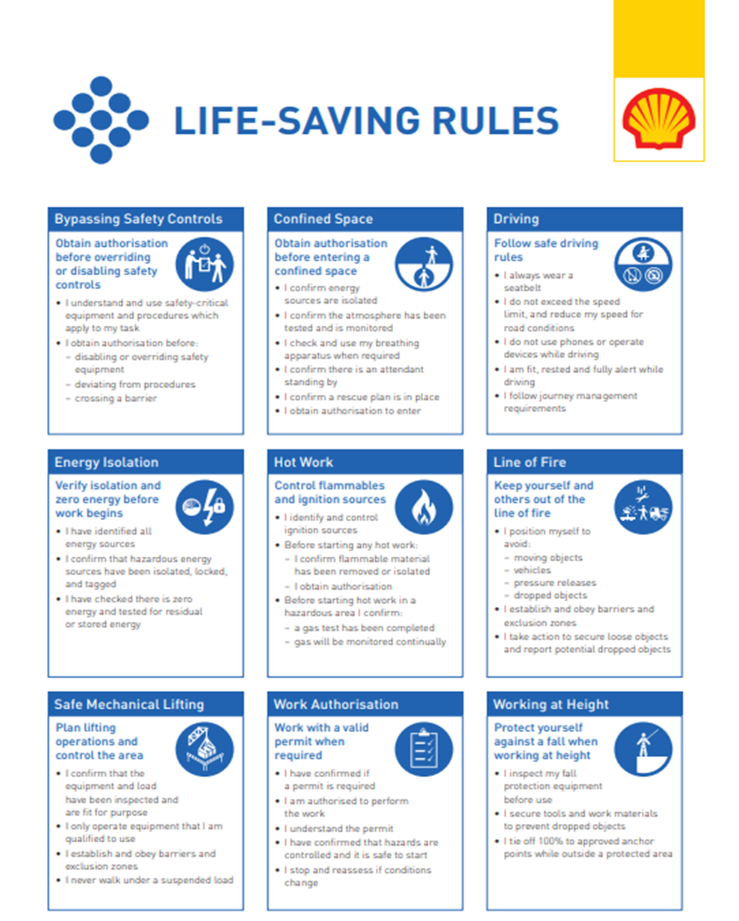

**11.1 ULLAGING AND SAMPLING:**

During loading and for 30 minutes after the completion of loading (relaxation-time) no equipment for dipping, ullaging or sampling may be introduced into the tank.

Portable gauging devices mounted on deck standpipes such as UTI's and operations through correctly designed and installed sounding pipes - pipe which extends to the full depth of the tank - are allowed.

**11.2 CLOSED OPERATIONS:**

The loading, discharging and/or ballasting of ship’s cargo tanks must be conducted under closed conditions. The use of manual gauging/sampling of cargo tanks via sighting, ullage ports or similar openings is not permitted .

In case of exceptions e.g. Claim Procedure, then a MOC (process) is required.

**11.3 STATE OF READINESS OF MAIN ENGINES:**

The main engines and other essential machinery of all ships alongside must be maintained in a state of readiness for vacating the berth at short notice

**11.4 MAINTENANCE AND REPAIR WORK ONBOARD:**

Major planned repair work is not permitted while the ship is alongside the Shell Pernis Berth. Emergency repairs, namely essential repairs needed to rectify malfunctioning equipment and prevent hazardous or unsafe conditions, will be permitted on a case-by-case basis following upon application to the Harbour Master and with the permission of the Terminal Representative.

**11.5 HOT WORK ON BOARD:**

Hot work outside a designated space is not permitted on board ships alongside the Pernis Berth

**11.6 TANK CLEANING, PURGING AND GAS FREEING:**

During ships stay at our jetty all cleaning operations and tank entries are prohibited. If a vessel alongside is rejected, she has to leave the berth and proceed to another berth / anchorage for cleaning.

**11.6.1 Crude Oil Washing**

**Shell Energy and Chemicals Park Rotterdam** critical for the Ferron (FE) content in the crude oil, therefore we request you :

a. To keep 1000 (Jetty 102), 1500 (Jetty 103) to 1700 m3 (Jetty 104) clean cargo apart from the COW, to be discharged at the end in order to flush shore line

(*) exact quantity to be confirmed by the loading master , once ship has been allocated a jetty for this call

b. to perform a Closed-cycle Crude Oil Washing and keep all washings well segregated from the ‘clean oil’.

c. to discharge the crude oil washings as a separate parcel at the end of the standard discharge operation. Before you will commence the discharge of this last parcel, please advise the Terminal, and , upon completion of this parcel , also advise the Terminal

d. Once Terminal gives you the agreement , flush the shore line by discharging the remaining clean cargo ( ref item a))

Kindly confirm understanding & feasibility ( or of not clarify) , as well as potential consequences on discharge operations ( if any) .

**APPENDIX A: CONTACT LIST:**

|  |  |  |  |
| --- | --- | --- | --- |
|  | **telephone** | **E-mail** | **opening hours** |
| Emergency General  Deputy PFSO /Security Dept | +31 10 431 8000 |  |  |
| Loading master Shell Europoort  (for operational matters only) | +31104311240  +31 6 52511187 | SNR-ROM-Wachtchef-REU@shell.com | 24 hours |
| Harbour number: | 5740 | N/A |  |
| Visiting address | Rijndwarsweg 21  3181 LK Rozenburg |  |  |
| Emergency number  LM oil office  Emergency number  LM Chemical office | +31 10 431 4188  +31 10 431 1670 | N/A |  |
| Loadingmaster Oil  Loadingmaster Chemie | +31 10 431 1599  +31 10 431 1670 | SHELL ENERGY AND CHEMICALS PARK ROTTERDAM-ROM-OA-Loadingmaster  [SHELL ENERGY AND CHEMICALS PARK ROTTERDAM-CVP-Loadingmaster@shell.com](mailto:SNR-CVP-Loadingmaster@shell.com) | 24/7 |
| Control room SHELL ENERGY AND CHEMICALS PARK ROTTERDAM  (for operational matters only)  Chemie | +31 10 431 3929  +31 10 431 4250 | [SHELL ENERGY AND CHEMICALS PARK ROTTERDAM-ROM-Panel-BCO@shell.com](mailto:SNR-ROM-Panel-BCO@shell.com)  MWC.CFD@shell.com | 24/7 |
| Harbour number:  Visiting address | 3223  Vondelingenweg 601  3190 GB Hoogvliet | N/A |  |
| MTA | +31 6 5251 1004 | N/A | Standard office hours |
| SHELL ENERGY AND CHEMICALS PARK ROTTERDAMVJetty Planning | +31 10 441 5063 | SNV-OEMS-JETTY-SCHEDULING@shell.com | Standard office hours. |